Lab 3 Submission
3. 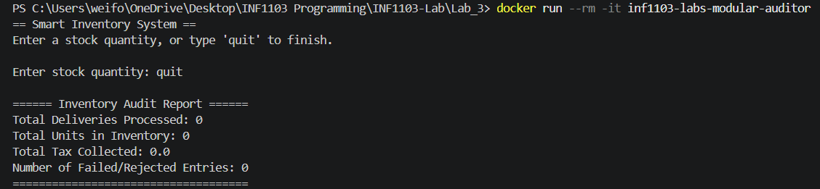
4. 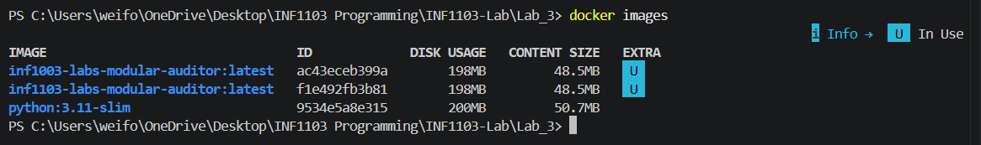
5. 